**DAILY ONLINE ACTIVITIES SUMMARY**

|  |  |  |  |  |  |
| --- | --- | --- | --- | --- | --- |
| **Date:** | **06 July 2020** | **Name:** | | **KHATHEEJA SAFREENA.** | |
| **Sem & Sec** | **4th sem, 2nd year** | **USN:** | | **4al18cs037** | |
| **Online Test Summary** | | | | | |
| **Subject** | **18MAT41** | | | | |
| **Max. Marks** | **----** | | **Score** | **---** | |
| **Certification Course Summary** | | | | | |
| **Course** | **FUNDAMENTALS OF DIGITAL MARKETING.** | | | | |
| **Certificate Provider** | **Google digital garage.** | | **Duration** | | **40 hours** |
| **Coding Challenges** | | | | | |
| **Problem Statement:1 program** | | | | | |
| **Status: Executed** | | | | | |
| **Uploaded the report in Github** | | | **Yes** | | |
| **If yes Repository name** | | | [http://shafreenasharief / lockdown-coding](http://shafreenasharief / lockdown-coding" \o "http://shafreenasharief / lockdown-coding) | | |
| **Uploaded the report in slack** | | | **Yes** | | |

Certification Course Details: (Attach the snapshot and briefly write the report for the same)

Coding Challenges Details: (Attach the snapshot and briefly write the report for the same)

#### ONLINE TEST:

#### Today we attended 18MAT41 first IA test.

#### 

**CERTIFICATION COURSE SUMMARY**:

Today I started new course **FUNDAMENTALS DIGITAL MARKETING** through **GOOGLE** **DIGITAL GARAGE** the course is secluded for 6hrs. After the completion of course, certificate will be provided. I completed all the module .I attempted quiz ,which gave me a clear veiw about the topics that were thought and discussed.It consists of 7 modules which also include assessments.



**CODING CHALLENGES:**

Today I solved 1 coding challenge,

1**. Write a Java program to find the Nth natural number with exactly two bits set**   
Given an integer N, the task is to find the Nth natural number with exactly two bits set.  
Examples:

Input: N = 4  
Output: 9

Input: N = 15  
Output: 48

**Hint**  
***Explanation: of 1st example***  
Binary representation of numbers 1 -0001, 2- 0010, **3- 0011**, 4-0100, **5-0101**, **6-0110**, 7- 0111, 8-1000, **9 - 1001**, **10- 1010** etc. Here only for the bold numbers binary values contains exactly 2 bits 1's hence  
Numbers with exactly two bits set: 3, 5, 6, 9, 10, 12, …  
4th number in this is 9.

**output:  
9**

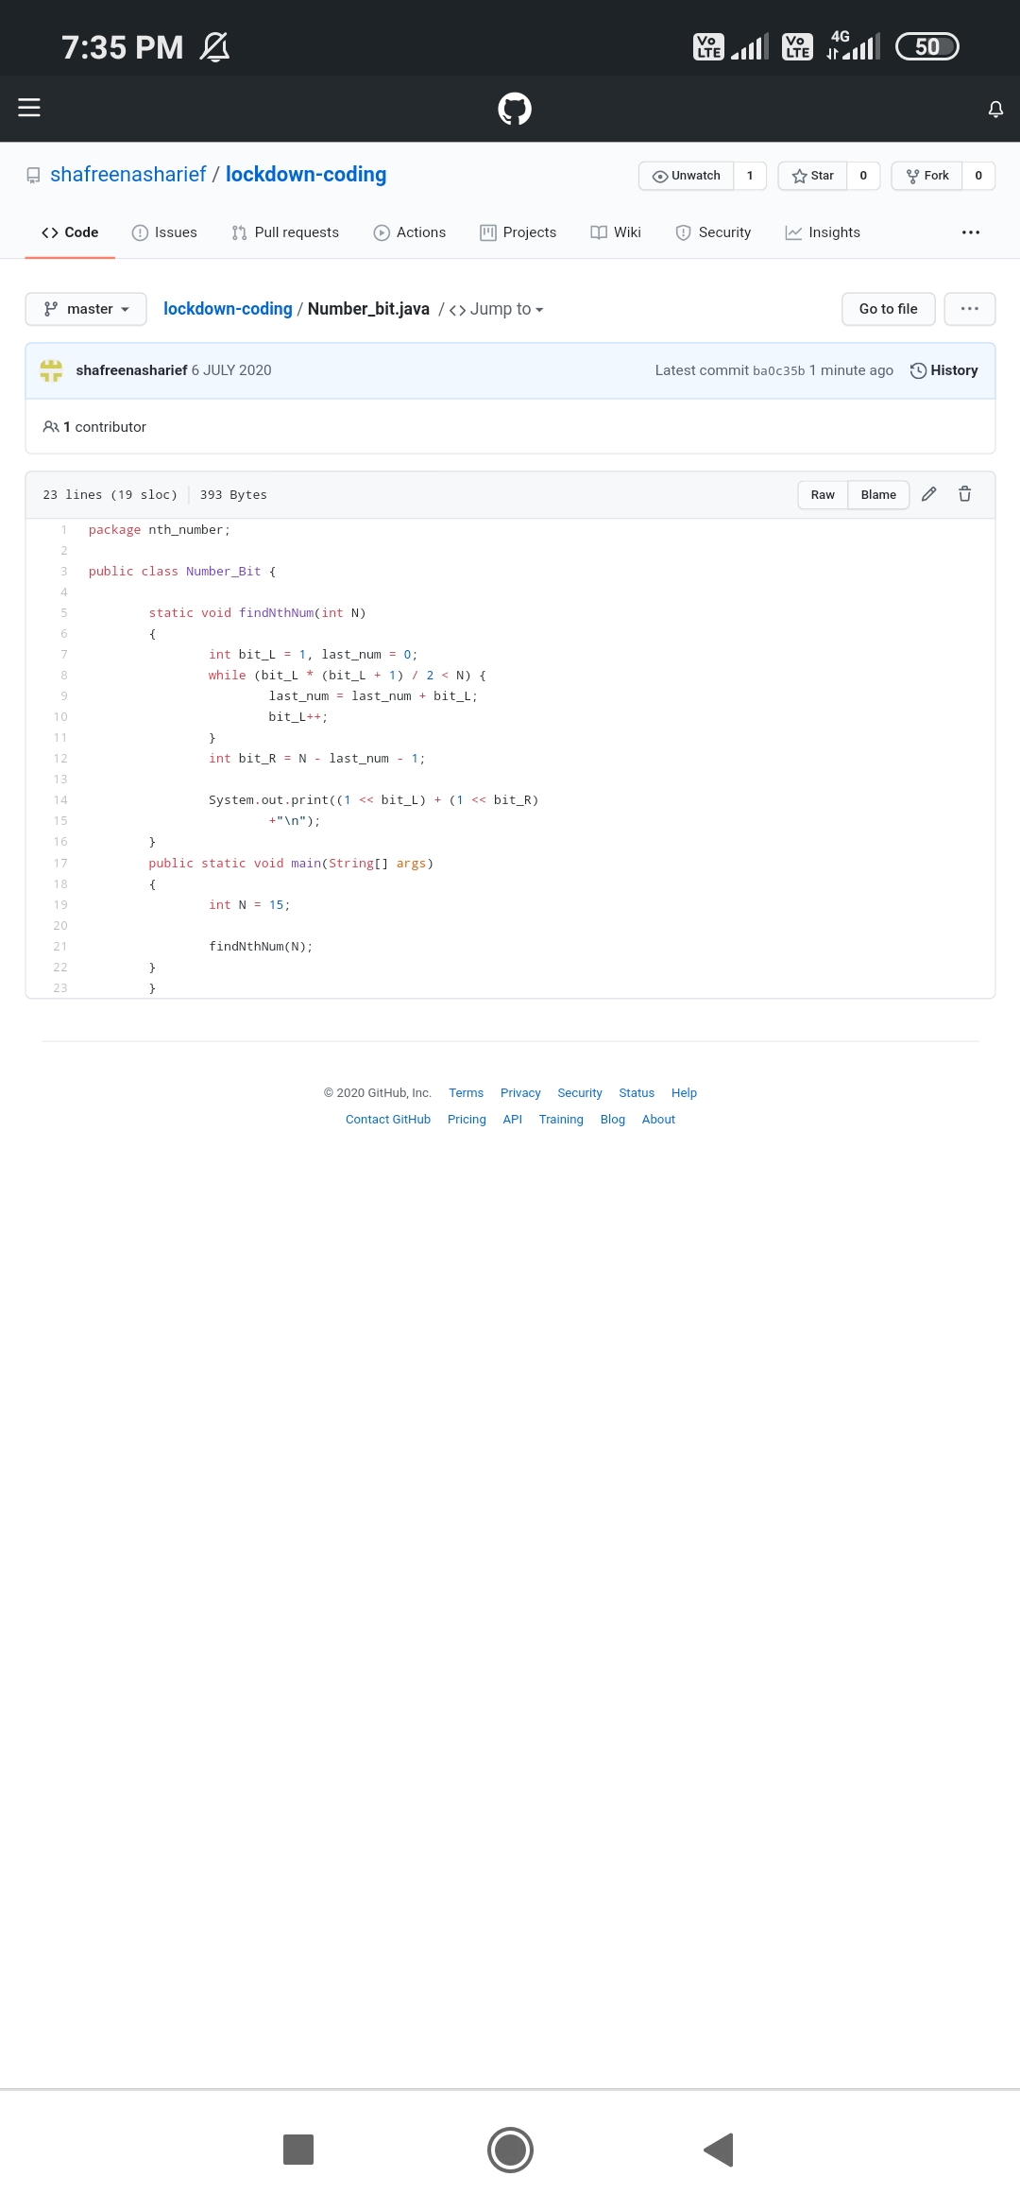

**ONLINE WEBINAR:**

**Today we attended the session on Salesforce - Job ready program at Time: 11.30AM.**

[http://shafreenasharief / lockdown-coding](http://shafreenasharief / lockdown-coding" \o "http://shafreenasharief / lockdown-coding)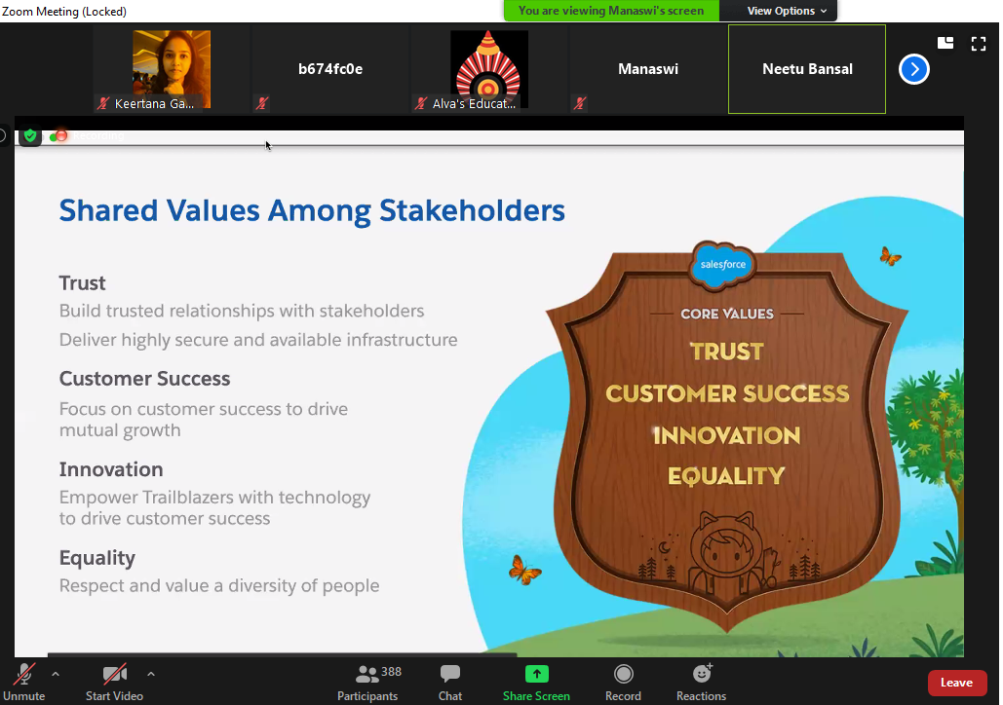

Afternoon we attended the webinar TCS iON Session on How to use Remote Internship Opportunities at 2:15.

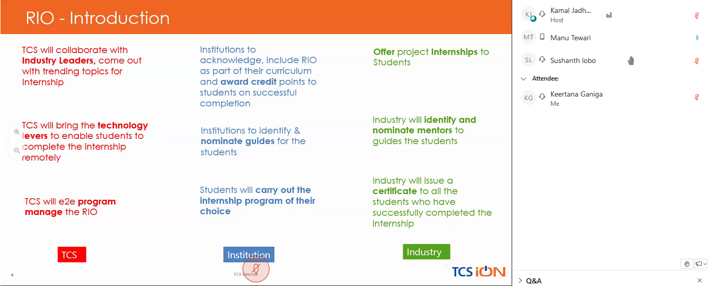

**SOLUTION** : I have uploaded the solution of the above 1 coding problems in my GitHub repository.

[http://shafreenasharief / lockdown-coding](http://shafreenasharief / lockdown-coding" \o "http://shafreenasharief / lockdown-coding)

[http://shafreenasharief / locked-down--certification-course](http://shafreenasharief / locked-down--certification-course" \o "http://shafreenasharief / locked-down--certification-course)

[http://shafreenasharief / Daily\_Report](http://shafreenasharief / Daily_Report" \o "http://shafreenasharief / Daily_Report)